**Figure 1a. West Nile Virus Surveillance Vector Index for all *Culex* by zone (2006-2019).**

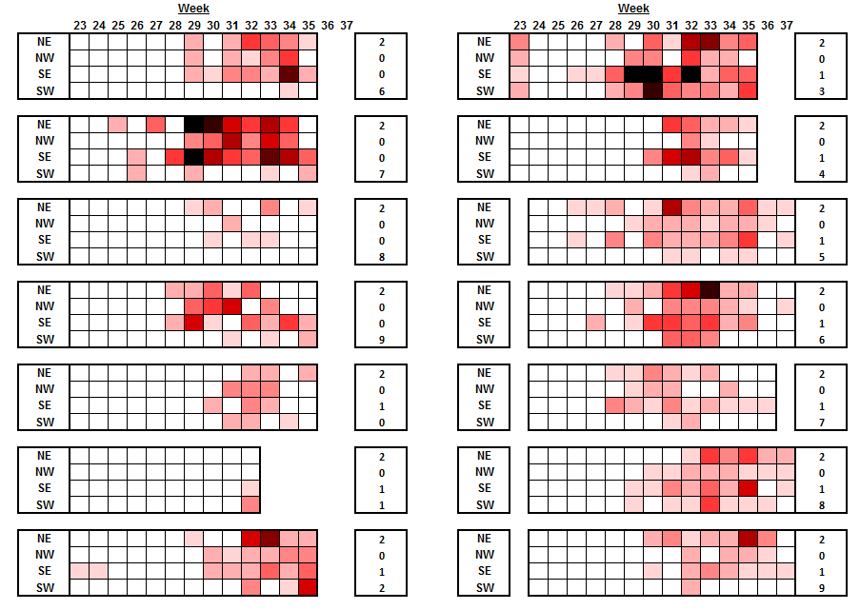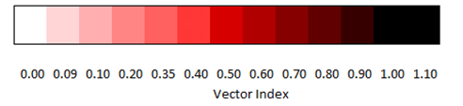

**Figure 1b. 2019 WNV surveillance Citywide Vector Index in relation to (2006-2018) historical averages.**



**Figure 1c. 2019 WNV surveillance Citywide Vector Abundance in relation to (2006-2018) historical averages.**

